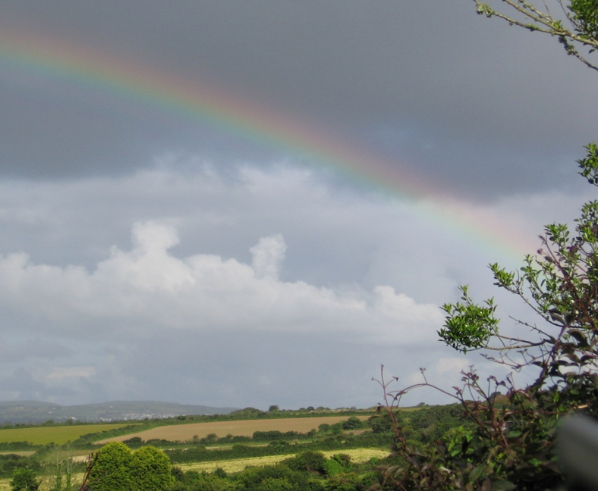

ANNUAL SALE & COFFEE MORNING

A MOST SOCIABLE & FRIENDLY COUPLE OF HOURS!

HALL FOR GWINEAR
SATURDAY 16th MAY 2015
10 am to 12 noon

REFRESHMENTS - HOME PRODUCE
WHITE ELEPHANT - BOOKS - RAFFLE

PLEASE JOIN US FOR THIS IMPORTANT OCCASION TO RAISE FUNDS TO SUPPORT THE UPKEEP OF OUR FOOTPATHS AND BRIDLEWAYS

CONTACT: Geoff Webster - Phone 01736 851173 - Mobile 07980 198023

