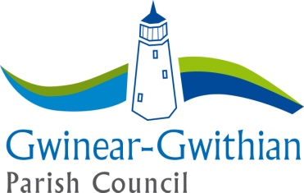

GWINEAR-GWITHIAN PARISH COUNCIL
CONSENT FORM

“Your privacy is important to us and we would like to communicate with you about the council and its activities. To do so we need your consent. Please fill in your name and address and other contact information below and confirm your consent by ticking the boxes below.”

Please confirm your consent below. You can grant consent to any or all of the purposes listed. You can find out more about how we use your data from our “Privacy Notice” which is available from our website - www.ggpc.org.uk or from the council office.

You can withdraw or change your consent at any time by contacting the council office.

We may contact you to keep you informed about what is going on in the council‘s area or other local authority areas including news, events, meetings, clubs, groups and activities. These communications may also sometimes appear on our website, or in printed or electronic form (including social media).
We may contact you about groups and activities you may be interested in participating in.
We may use your name and photo in our newsletters, bulletins or on our website, or our social media accounts (for example our Facebook page or Twitter account).

Keeping in touch:
Yes please, I would like to receive communications by email
Yes please, I would like to receive communications by telephone
Yes please, I would like to receive communications by mobile phone including text message
Yes please, I would like to receive communications by social media (for example Facebook, Twitter, Instagram, WhatsApp)
Yes please, I would like to receive communications by post

 |  | If you are aged 13 or under your parent or guardian should fill in their details below to confirm their consent
Name | ……………………………………….................... |  | …………………………………………….............
Address | ……………………………………........................ |  | ……………………………………………............
 | ……………………………………….................... |  | ……………………………………………............
 | ……………………………………….................... |  | …………………………………………….............
Email  Telephone | ............................................................................  ............................................................................ |  | ..........................................................................  ..........................................................................
Signature | ……………………………………….................... |  | ……………………………………………...........
Date | ……………………………………….................... |  | ……………………………………………...........

Gwinear-Gwithian Parish Council . Unit 3 Bosprowal Farm . Penhale Road . Carnhell Green . Camborne . Cornwall . TR14 0LU
Tel: +44 (0)1209 614618 (Parish Office) . email: clerk@ggpc.org.uk . www.ggpc.org.uk
Chairman: Councillor Steve Rowe. Vice Chairman: Councillor Michael Roberts/Mike Smith. Clerk: Mrs Vida Perrin

