Using online resources can be a great way to support your health. They can be helpful in several ways, including:
- Improving knowledge: You can search the internet for information about health problems, their symptoms and treatment options.
- Increased ability to make more informed decisions about your healthcare enabling you to feel more confident in the treatment you receive

And remember …. Crucially by using online when you can you will be helping to reduce the pressure on the NHS at this critical time.

Learn about
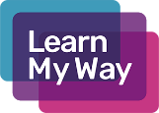
Use Learn My Way to you help understand how to book a GP appointment online and take you through the NHS Choices website
https://www.learnmyway.com/subjects/improving-your-health-online/

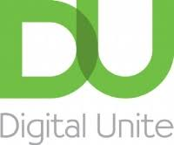
Using the links below from the Digital Unite website will help you to understand how use the NHS app and NHS websites to manage your health online and how to register for online services
https://www.digitalunite.com/technology-guides/health-and-fitness/using-nhs-app-and-nhs-websites-manage-your-health-online

https://www.digitalunite.com/technology-guides/health-and-fitness/registering-nhs-online-services

Look for
NHS Choices has a complete A-Z of health conditions and medicines – a fantastic resource packed full of information
https://www.nhs.uk/

If you need help but it’s not an emergency, why not try
https://111.nhs.uk/

Everyone in Cornwall can help the UK's response by following Public Health England's guidance which is being updated regularly
https://www.cornwall.gov.uk/health-and-social-care/public-health-cornwall/information-about-coronavirus-covid-19/

Check out these recommended best medical websites if you are looking for health information
https://www.digitalunite.com/node/6088/best-medical-websites

