Using the internet to purchase goods or services saves considerable time and effort and also presents you with the widest choice. The main advantage of online shopping is that it enables reduce your monthly expenses. Most online stores offer lower prices, as opposed to offline stores, as well as offer various bargains that help save even more money.

Learn about
Use the following online resources to help you to learn about shopping online safely

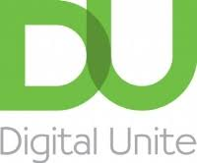
Digital Unite – How to buy online
https://www.digitalunite.com/technology-guides/government-services-shopping-banking/online-shopping/internet-shopping-how-buy
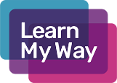
Video – Learn My Way
https://www.youtube.com/watch?v=tc1eDwkkVZE

Learn My Way - The course covers how you can use the internet to compare prices, your rights when buying online and secure payment methods you can use when shopping online.
https://www.learnmyway.com/courses/online-shopping/

Look for
Website – Money Advice Service shopping online
https://www.moneyadviceservice.org.uk/en/articles/shop-safely-online

Get Safe Online
Using the internet to purchase goods or services saves considerable time and effort – and presents you with the widest choice. There are, however, risks associated with online shopping and you need to take care with what you are buying, from whom, and how you pay for your purchases.
https://www.getsafeonline.org/shopping-banking/shopping1/

How to Shop Safely Online
Online has become the most popular way to shop, so knowing how to stay safe whilst making purchases on the Internet has never been more important. Find out the key things to look out for with our online shopping safety guide.
https://www.plus.net/home-broadband/content/how-to-tell-if-a-website-is-safe/

